***Government College of Engineering, Bargur.***

***SMART PARKING USING IOT***

Gowtham. B 61072111115

Aarthi. R 61072211901

Kaviya. S 61072211909

Ranjith kumar. M 61072211914

***OBJECTIVE***

* The main aim of this project is reduces the risk of finding the parking slots in any parking area
* It eliminates the unnecessary travelling of vehicles across the filled parking slots in a city

**INTRODUCTION**

Internet of thing (IOT) has the ability to transfer data through network without involving human IoT allows user to use affordable wireless technology and also helps the user to transfer the data into the cloud . IOT helps the user to maintain transparency. The idea of IoT started with the Identity of things for connecting various devices. These devices can be controlled or monitored through computers over internet. IoT contains two prominent words “Internet” and “Things”, where Internet is a vast network for Connecting servers with devices [1]. Internet enables the Information to be sent, receive or even communicate with the devices. The parking problem causes air pollution and traffic congestion [4]. In today’s scenario, parking space is hard to search in a day to day life for the people. According To the recent survey, there will be a rapid increase in the vehicle’s population of over 1.6 billion around 2035 [7]. Around one million barrels of world’s oil is being burnt everyday [4]. Thus, smart parking system is the key solution to reduce the waste stage of the fuel. The solution for the problems that is being raised. The smart parking can be a solution to minimise user’s time and efficiency as well as the overall cost of the fuel burnt in search of the parking space. In this, the data is collected from the sensor and through analysing and processing, the output is obtained.[5]

**EXISTING SYSTEM**

In the Existing System they use parking camera for detecting the number of available cars in the parking area using threshold optimizing technique in image processing. The camera send the information to the fog node, fog nodes process the pictures from multiple camera in order to identify the number of available parking slots. Fog nodes connect to cloud through proxy server and user can access the information using internet .Fog nodes deployed at parking lots, cooperating with each other, enable real time parking slot information provisioning as well as parking requests processing. The cloud centre will enforce global optimization on parking requests allocation. The experimental results of our approaches show higher efficiency compared with other parking strategies. The fog computing-based smart parking can lower the average parking cost and minimize gasoline wastes and vehicle exhaust emission. One main disadvantage of the existing system is the user will not know the shortest path available to the parking slots. For example, if there are slots 2 and 5 free and cloud will not update the shortest path available to the user and this may lead to high fuel consumption in search of the parking slot.

**DISADVANTAGE**

The existing system will send the information from the cameras to fog nodes and it takes higher time for processing of these images. The user will not be aware of the shortest available parking slot in the parking space and also the user will not know are there any available parking slots in the parking space before entering. Resources such as fuel and time are wasted in search of the parking slot. The search for the parking slot will also leads to accidents because the users will be less focusing on road while searching

**PROPOSED SYSTEM**

We will make of micro-controller and this is used to process the instructions continuously in a loop. The user will first scan the RFID card using the RFID reader and the webpage will update the user details and even before the user scans the RFID card, the web page will display is there any available parking slot or not. After updating the user details on web page, a DC motor is used to open the gate for the user.Now the web page displays the available parking slots as well as the nearest parking slot to the user. IR sensors are used for the object detection in the paper and by object in this is the vehicle. As soon as the user parks the vehicle in the parking slot, the IR sensor will detect the object forwards the information to the micro controller and the micro controller will process this information and update on the web page.

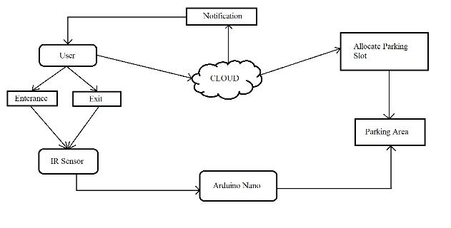**System Architecture**

**Hardware**

The three main hardware components used are GMS Module, RFID card, IR sensors. A user is allowed inside a Parking space only if the user has a RFID card. RFID card Contains the information of the registered user. As the car Enters the parking slot, reader module scans the registered User’s RFID tag. The data is sent to the ardunio for checking **.**The availability of the car parking and simultaneously, the User is notified through SMS about the status of the parking Area. The GSM module sends the message according to the Availability. IR sensor sends the signals according to the Presence of the vehicle.

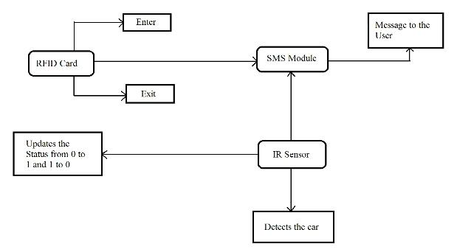

**Hardware Architecture**

**Software**

The cloud server acts as a mediator between the modules. The cloud server is connected to the Wi-Fi to. The user Receives messages through the SMS module while the car Enters and exits the parking area using RFID card. The Messages sent by the SMS module are managed by the Cloud. As soon as the IR sensor detects the car, the status of The cloud will be updated from 0 to 1 and when the car Leaves the parking area the status of the car will be updated From 0 to 1.

**.**

**Software Architecture**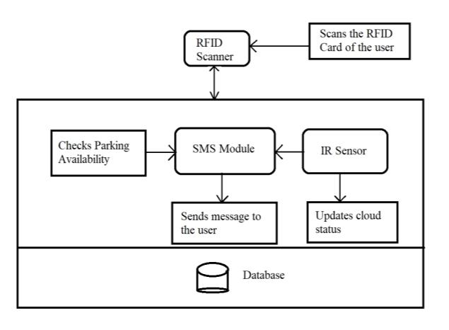

**DETAILS OF THE MODULE**

1. **GSM Module:**

The GSM module is a circuit which is used to setup communication between mobile phones and microcontroller .It is used to send SMS, MMS and voice messages through mobile network. GPRS extension in GSM allows high data transmission. GSM uses time division multiple access approach for transmission.

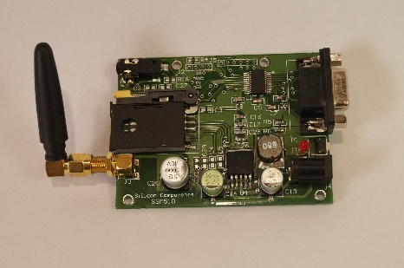

1. **IR Sensor :**

An infrared sensor is basically an electronic device which is used to detect the presence of objects. Infrared light is emitted by this device. If this device does not detect any IR light reflected back that means there is no object present. If the light is detected by the sensor there is an object present.

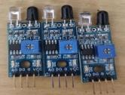

1. **RFID Card :**

RFID tags are made up of integrated circuit (IC), an antenna, and a substrate. It is an identification badge or credit card that transfers its contents about an object to the reader module. RFID tag transfers data about an object through radio waves. When RFID tags are attached to devices they can also be used for tracking

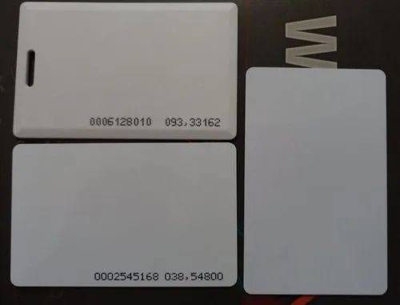

**D. READER Module :**

This module is a device which scans and gathers the information from the RFID Card. This card can be used to track objects. As the car enters the parking area, the user scans the RFID card and all the information stored in card is transferred to the admin through this module.



1. **Servo Motor :**

It is a rotator device that allows the control of angular as well as linear motion. A servo motor is used for the opening and closing of the gate. Servo drive transmits electrical signals to the servo motor for producing motion.

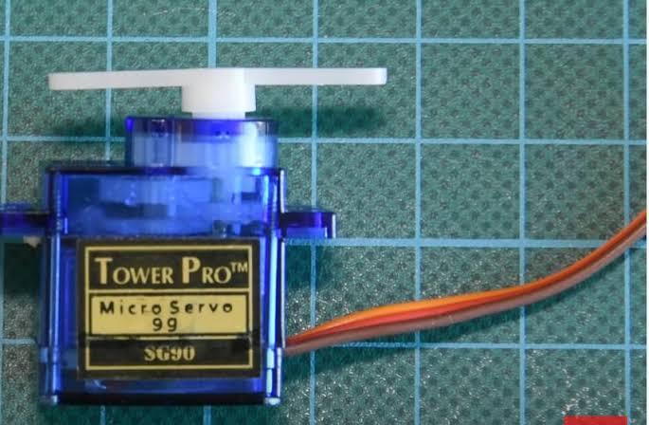

1. **Arduino Nano:**

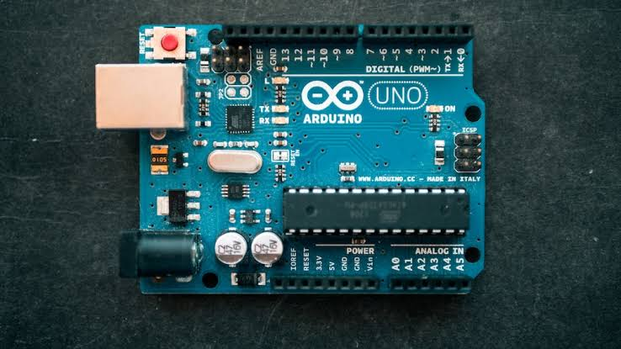It is a compact board which can be used in various devices and various field. It has overall 22 input/output pins out of which 14 pins are digital pins. It has a flash memory of about 32 kb. These pins can control the operations of digital pins as well as analogy pins. This module is a breadboard friendly board which can be easily used anywhere.

1. **WIFI Module:**

It is used to send data from embedded system to the internet using URL by HTTP POST method using TCP/IP protocol. It is developed by espress if systems. It is a 32 bit microcontroller with 80kb user data. It contains 16 gpio pin

